Web is a system of various resources and document are interconnected which is accessed via internet.

Internet is an entity and web is like a service. Web is a subset of internet.

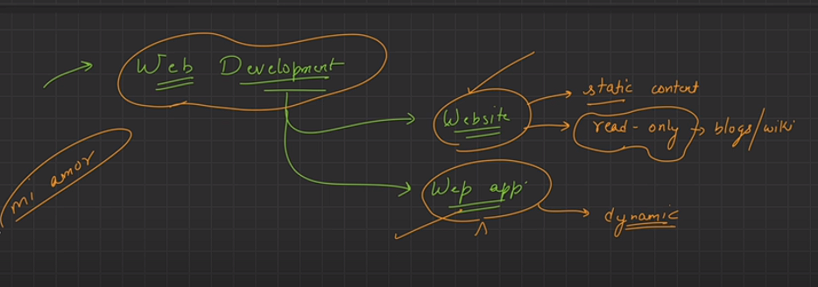

In web app user interaction is possible and vise versa in website. (negligible)

The component which is visually represented at your website is known as front end or UI.

All the logic and functionality are defined at backend.

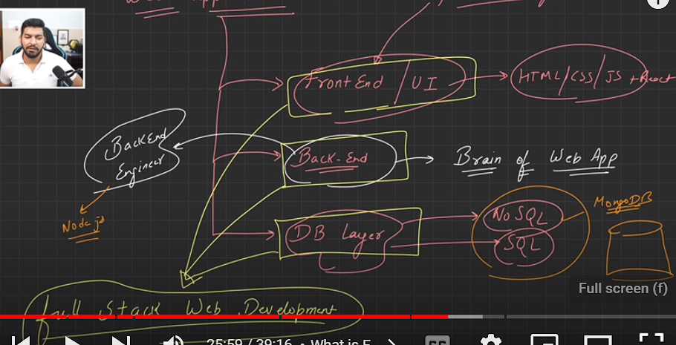

THREE LAYERS OF WEB DEVELOPMENT

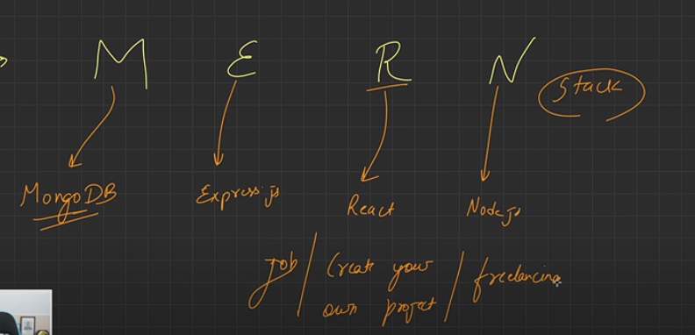

Various resources (computer, printer, mobile phones) are interconnected through a system and communicate is known as Network.

They are dividing on the basic of scale…….

LAN- Router in a home

MAN- city town and state are interconnected.

WAN- if countries are interconnected and communicate, resource sharing and conversation.

**Internet-** It is a global system or network of networks in which all the resources (billions of devices) are connected.

**IP address –** if your system is existed on the internet then your system has a IP address through which it can be uniquely identified.

**Browser –** A tool by which we can access all these resources, documents, website and webpage on internet is known as browser. Example – Google Chrome, Safari, Opera, Mozilla Firefox.

**Browser Engine –**

**Client/Server-**

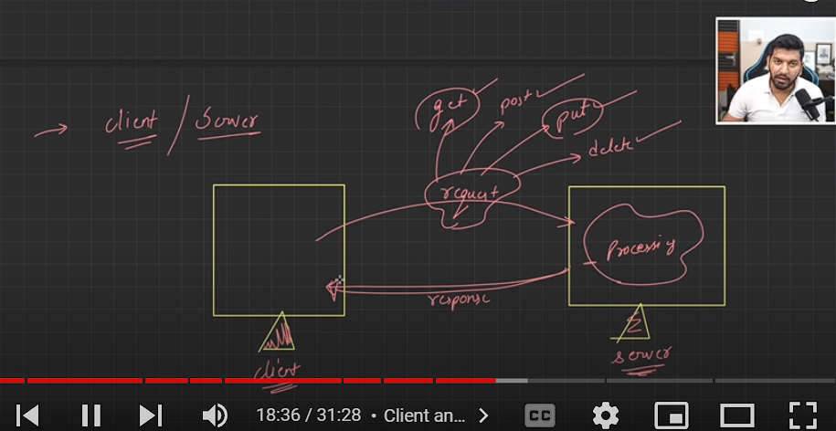

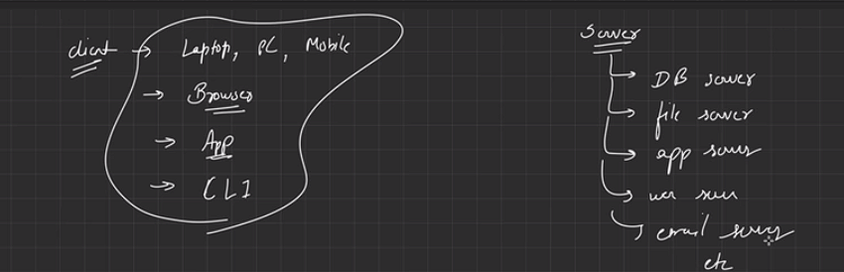

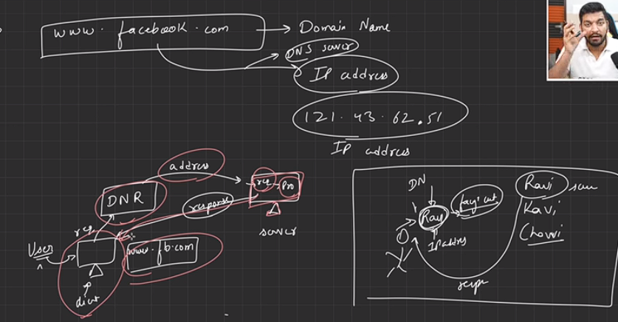

Network : Interconnected different resources(Computer, print, laptop) within single system. 2) Internet : It is globle system that exists billions of device interconnected with each other (network of networks) 3) Web : Interconnected documents, devices and resources access using internet. 4) IP Address : Address for identify each device uniquely. 5) Browser : It is a tool to access documents, websites, web applications. 6) Browser Engine : It is an application which is is used to access resources[websites, web applications]. Ex. (Chrome(Google), Safari(Apple), Firefox, Opera) 7) Client : Who request for something (Requests ex. Get, Put, Put, Delete) Ex. Laptop, PC, App 8) Server : Who full-fill requests of client. Ex. App, Web, DB, File 9) DNS[Domain Name System] : It convert domain name into IP address.

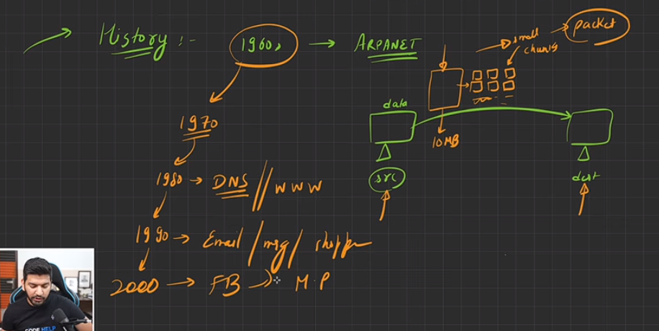

ISP (Internet Service Provider) – Airtel and JIO, it provides an IP to work over an internet.

**Packets-** when a big file is broken into pieces or chunks and that chunks of file is known as packets.

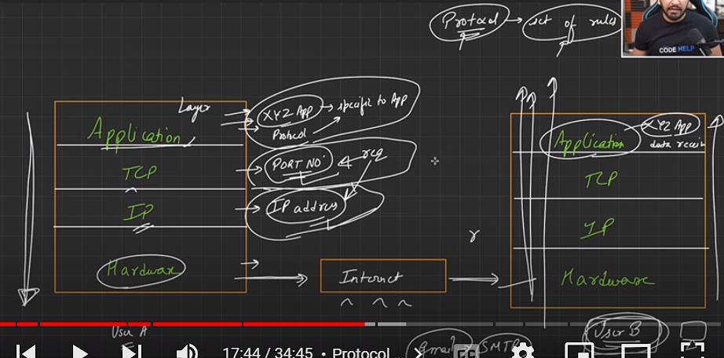

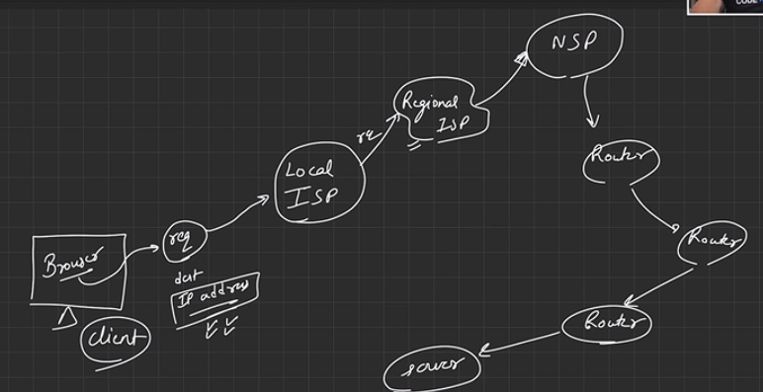

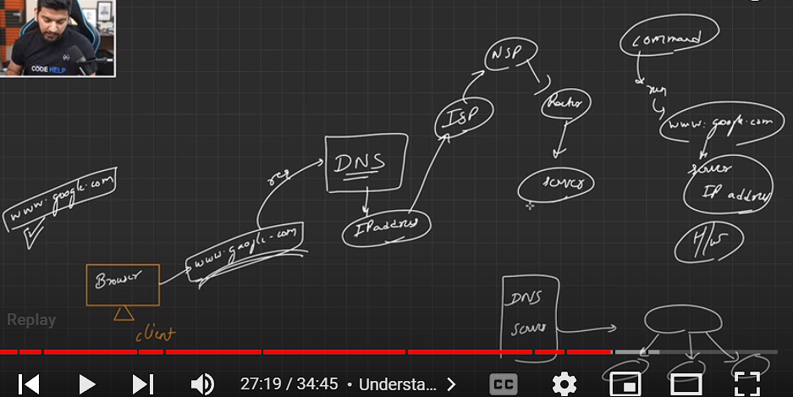

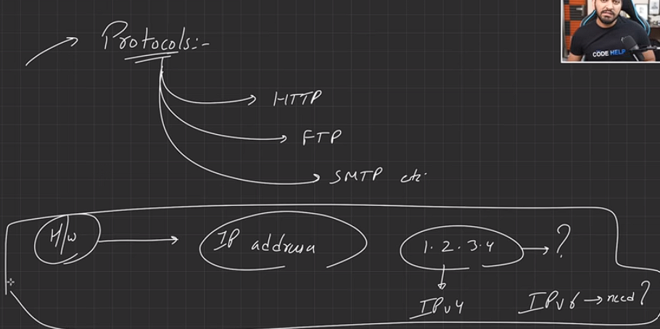

IPv4 has a 32-bit address length. IPv6 has a 128-bit address length. Generally, IPv6 is faster than IPv4. However, when we go to a larger packet size, IPv6 can be slow in some cases. need of ipv6 is to improve security and support for mobile devices ....

**HTML-** It is a language, HTML we define the labelling (Heading, image and video) of our webpage and define the structure and description of our website. It basically answers the what part of our website.

**CSS –** Styling and appearance part define

**JAVA SCRIPT-** all the logic and functionalities defined like a brain

**Tag-** AnHTML tags are **like keywords which defines that how web browser will format and display the content**.

**Element-** An HTML element is **defined by a start tag, some content, and an end tag.**

<!DOCTYPE html> show we are using html 5 version.

Html tag show all the data should be written within html tag. It is a root element.

In head tag we generally store meta data, SEO, and title etc. we can also link style sheet (CSS).

In body tag we put those content which we want to display and user will interact with those content. And all the labelling content of website is done in body tag.

Tag is a markup entity which is used to provide or define Semantics or meaning, structure and formatting of a webpage.

**Markup means we mark or specify h1 tag is used for heading and header tag is used for header content.**

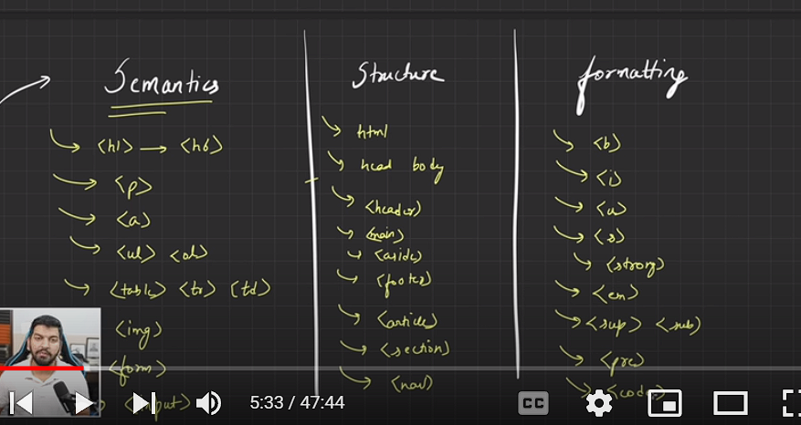

<br> is a self closing tag. Which basically change the line.

We can use multiple h1 tag or not?

**Anchor tag is used to create hyperlink to a web pages, files, email addresses, location in the same page.**

**Hyperlink means from one document we can reach to another documents.**

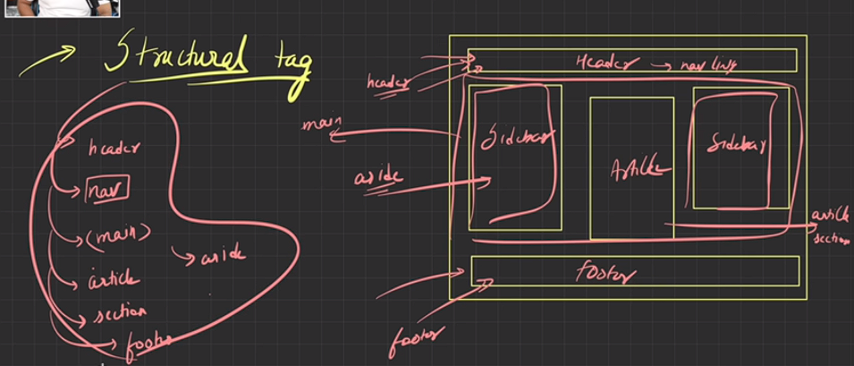

**25:30 and 44:00**

Emmet is a software plugin which is by default installed in a VS code. By using Emmet we are using some shortcut to generate a full code of HTML.

Id attribute har element ko uniquely identified karta hai

Class basically element grouping ke liye use krte hai. In class there is multiple element can exits.

Div tag is a kind of non-semantics tag. It is used in wrapping of large code and element or used as a container.

It is used to create division of code or web page, if our code is too large.

There is two type of element exits in html block element and Inline element

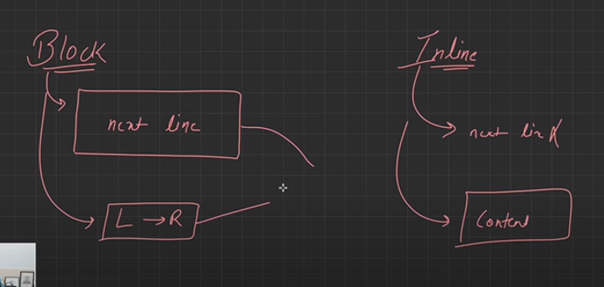

A block-level element always starts on a new line and it occupies the entire horizontal space.

<p> tag is also a block element.

How to create a bookmark? Using anchor tag

what we have learnt in this lecture?? 1. Emmet abbreviations.. > (for nesting) + (for next tag without nesting) #(for id attribute) . (for class attribute) {}( To write some content) 2. Div tag 3. Block and inline elements 4.Navigation bar (<nav> tag) 5. How to create Hyperlink , Email and telephone call using anchor <a> tag 6. HOMEWORK : a. Read block and inline elements from mdn. b. Can we convert a block element into inline element and vice versa? c**. How could i place content of list side by side instead of vertical?** d. How to remove dots in a list? e. How to create bookmark using anchor <a> tag?

1) Yes it's possible to convert inline to block and vice-versa by adding "display : inline" attribute while converting from block element to inline and vice-versa.

2) By nesting anchor tag in span tag we can create hyperlink in a single line.

3) By using style type="none" with li tag we can remove bullets.

We can convert block to inline using display : inline(CSS Property) We can place the list items side by side using display : flex(CSS Property) We can remove the bullet in list by using list-style-type : none(CSS property)

**Table:** Arrangement of data into rows and columns. We put data into cell.

tr tag is used to create row in a table and td tag is used to insert data into a cell.

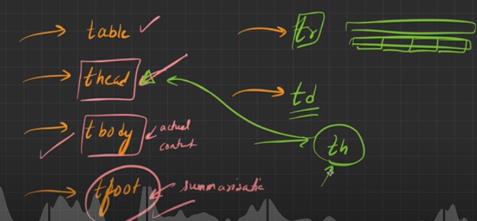

What we have learnt in this lecture?? - Tables in HTML - Tags used in tables in HTML

(<table> <thead> <tbody> <tfoot> <thh> <tr> <td>) –

row span : used to extend columns

col span : used to extend rows

**HTML Forms:-** It is a structure which is used to collect data or to collect user input.

form tag is used to create html forms for user input.

input tag used t take input and can be displayed into multiple forms like radio buttoms, check box, text field and date picker.

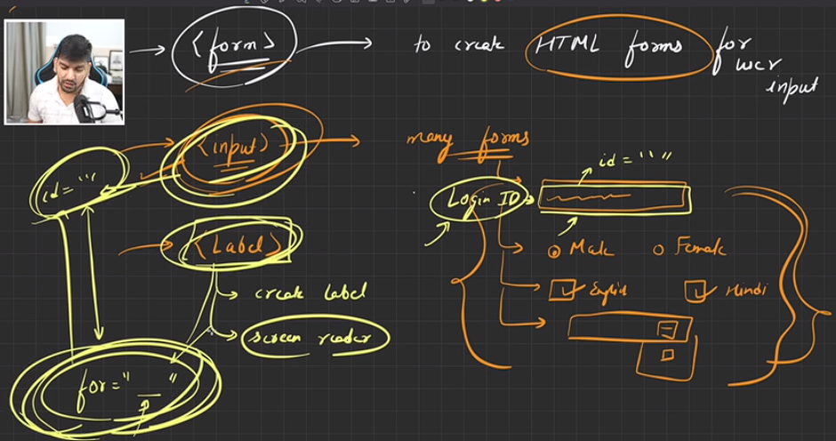

Label tag is used to create label that tell what to insert in that field like login id and password etc.

**In every label there is for attribute which is equal to input id attribute, basically for mapping.**

**Id attribute of input tag and for attribute of label tag is equal for mapping.**

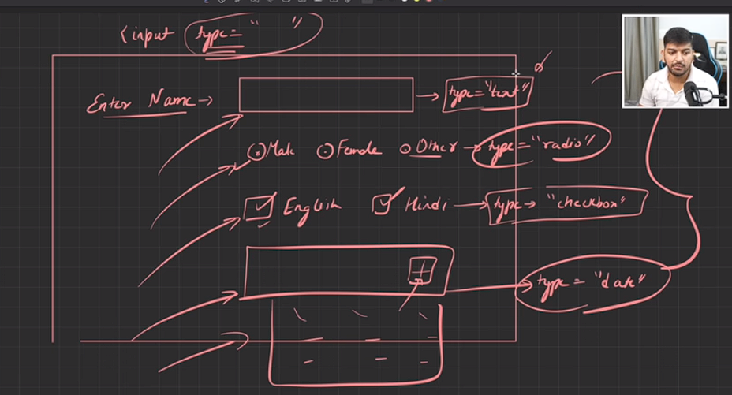

What we have learnt in this lecture ?? - HTML forms - Tags used in HTML forms ( <form> , <input> , <label> , etc. ) –

Input types ( textfield , button , radio , checkbox , file , image-button , password , date-picker ) - Form elements ( input , label , select , option , button , textarea **, fieldset , legend** ) - NOTE : i) By default type of <input> tag is ''text" ii) (for = " ") of <label> tag should be equal to (id = " ") of <input> tag. iii) Placeholder (It gives user a hint that what should be written here , i.e. FADED TEXT) –

HOMEWORK : i) Is it possible to select multiple options in a dropdown menu? If yes , find how its possible. ii) How can i select only one radio button? iii)Read HTML forms from MDN and W3SCHOOLS.

Placeholder? -> faded text like enter your email

textarea is used to take multiline input.

fieldset is used for grouping of element and legend is used to give caption to groups of element or fieldset.

Select tag is used to create drop down menu option and option is used to give options.

Answer-1 ) To select many options we should include 'multiline size="2",(here size sets how many options to display while selecting ' in select element.

Answer-2) To select one radio/option we should include value ="male " or "Female" or "not to prefer" in every input element.

home work 1= using multiple attribute we can change multiple option.

home work2= Replace name="radio1" in all the radio buttons.

In HTML, the <select> tag is used to create a drop-down list, also known as a select element. To allow multiple options to be selected, you need to add the multiple attribute to the <select>

I used the style method to make p tag inline by using (display: inline;)property <p style="display: inline;">Gender</p>

If we want a default value to be shown inside the options we can make one more option saying Select and add an attribute selected to it <option selected >Select</option> If we don't want it to be shown in the options then we can add hidden or disabled attribute to it so that when select the options it is not displayed <option selected hidden disabled>Select</option>

<section>

            <!-- we use details tag then under which we use summary tag to ask a question and then answer -->

            <h2>Frequently asked question</h2>

            <details>

                <summary>What is your name?</summary>

                <p>My name is Avinash Singh</p>

            </details>

        </section>

**iFrame :-**

An HTML iframe is used to display a web page within a web page.

The HTML <iframe> tag specifies an inline frame.

An inline frame is used to embed another document within the current HTML document.

Header, nav, footer, main and aside tag is used to provide structure and semantics to html documents.

id is accessed using #tag.

When you include the attribute "loading=lazy" in an image tag, it tells the browser to delay the loading of the image until it is about to come into the user's viewport, or until the user starts scrolling towards it. This means that images located further down the page or outside the initial viewport are not loaded immediately when the page loads. Instead, they are loaded dynamically as the user scrolls or interacts with the page.

loading lazy is very useful because it can help in optimizing the loading time of a web page. The loading attribute specifies whether a browser should load an image immediately or to defer loading of off-screen images until for example:- the user scrolls near them.

head tag data is not generally visible to the user, we basically put SEO data here,

**A favicon is a small image displayed next to the page title in the browser tab.**

**Favicon image should be always placed in a root directory.**

**The <title> tag defines the title of the document. The title must be text-only, and it is shown in the browser's title bar or in the page's tab.**

**Meta tag is basically used to optimise SEO.**

* The <meta> tag defines metadata about an HTML document. Metadata is data (information) about data.
* <meta> tags always go inside the <head> element, and are typically used to specify character set, page description, keywords, author of the document, and viewport settings.
* Metadata will not be displayed on the page, but is machine parsable.
* Metadata is used by browsers (how to display content or reload page), search engines (keywords), and other web services.

HTML is providing skeleton, structure, description and semantics of a webpage

CSS:- it provides styling or if want to enhance appearance of a web page.

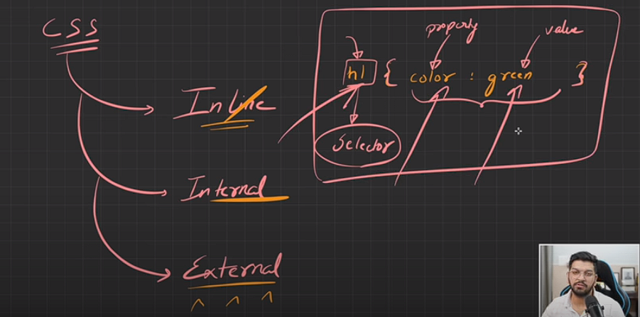

CSS can be added to HTML documents in 3 ways:

* **Inline** - by using the style attribute inside HTML elements
* **Internal** - by using a <style> element in the <head> section
* **External** - by using a <link> element to link to an external CSS file

What is selector?

Selector is a way in which we can target html element or multiple html elements and we can apply CSS on it or add style configuration.

**There is element selector, class selector, id selector and group selector.**

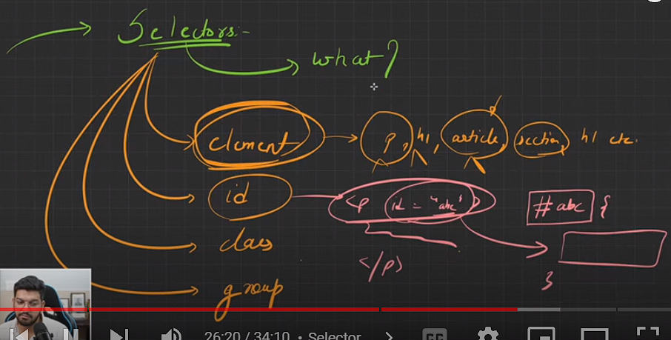

In element selector we can use tag name to style it.

In id selector we have to give id within html element and apply CSS on it. Id is unique for each html element.(#)

In class selector we group multiple html element (.)

In group selector we can style multiples html element using comma(,)

Css depends on 1. Specificity :- means priority of selectors Inline css > id > class > element

2. !important

3. Order in which cssis declared , the last one have higher priority

4. Inheritance means some css propertues will apply on all the elements insiade the selector like color but some not like border 4:12

4 factors on which css depend :- Order of declaration

Inheritance

Specificity

Media queries

1) Cascade- The one defined last in the stylesheet is taken into account 2) Specificity- The value which is specified mapped to the property of HTML element will be taken into account 3) Inheritence- if there are parent and child elements (nested) in HTML the value which is applied on the property of parent is applied to child unless specified separately

A typical definition, such as in CSS, is that a "physical" pixel is 1⁄96 inch (0.26 mm).

Font family define the way of alphabet defined in a particular family.

**We can set colour by four method named colour, rgb colour, hexadecimal value and hsl (hue, saturation and lightness**)

rgba here a means alpha which decides the **transparency** level of a colour.

**hsl(hue, saturation, lightness)**

**Hue-**

Hue is a degree on the color wheel from 0 to 360. 0 (or 360) is red, 120 is green, 240 is blue.

**Saturation-**

Saturation can be described as the intensity of a color. It is a percentage value from 0% to 100%.

100% is full color, no shades of gray.

50% is 50% gray, but you can still see the color.

0% is completely gray; you can no longer see the color.

**Lightness-**

The lightness of a color can be described as how much light you want to give the color, where 0% means no light (dark), 50% means 50% light (neither dark nor light), and 100% means full light.

**Width & height don't apply to the span tag because it is an inline element it will take space according to the content written in it.**

BOX MODEL:-

Box model simply refers to any content that we are rendering on a web browser is in rectangular box.

Explanation of the different parts:

* **Content** - The content of the box, where text and images appear
* **Padding** - Clears an area around the content. The padding is transparent, the space between content and border.
* **Border** - A border that goes around the padding and content.
* **Margin** - Clears an area outside the border. The margin is transparent or we can say the gap between two boxes.

Border ke inside gap padding and border ke outside gap margin.

**Universal Selector:- if we want to select all the element and tag and apply property, so we can use universal selector.**

**The box-sizing property allows us to include the padding and border in an element's total width and height.**

**If you set box-sizing: border-box; on an element, padding, and border are included in the width and height.**

**It retain the actual size of a box if we set box-sizing and srink content.**

**CSS display property:-** The display property specifies the display behavior (the type of rendering box) of an element.

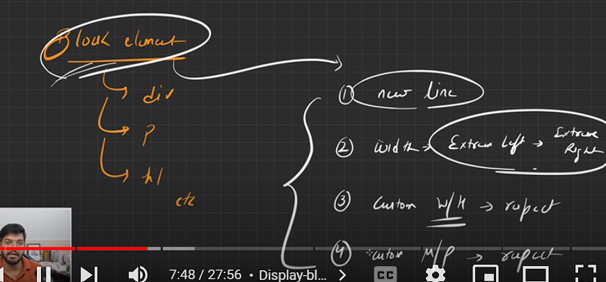

by default element will take width from extreme left to extreme right.

10 different type of block element?

Block Level Element:-

1. <div>: A generic container element used to group other HTML elements.

2. <p>: Represents a paragraph of text.

3. <h1> to <h6>: Heading elements used to define different levels of headings.

4. <ul>: Represents an unordered list.

5. <ol>: Represents an ordered list.

6. <li>: Represents a list item within an unordered or ordered list.

7. <table>: Represents tabular data.

8. <form>: Represents a form for user input.

9. <header>, <footer>, <nav>, <article>, <section>: Semantic elements used for structuring different parts of a webpage.

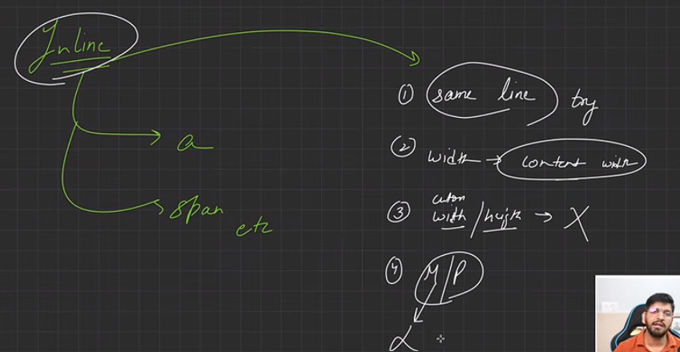

10 different inline elements are <label>, <input>, <span>, <textarea>, <button>, <img>, <em>, <br>, <a> and <select>.

Inline-block display property- it is an inline element but behave like a block element and allow custom width height margin and padding.

*Displays an element as an inline-level block container. The element itself is formatted as an inline element, but you can apply height and width values.*

CSS position property:- how we can position different element on screen

The position property specifies the type of positioning method used for an element (static, relative, absolute, fixed, or sticky).

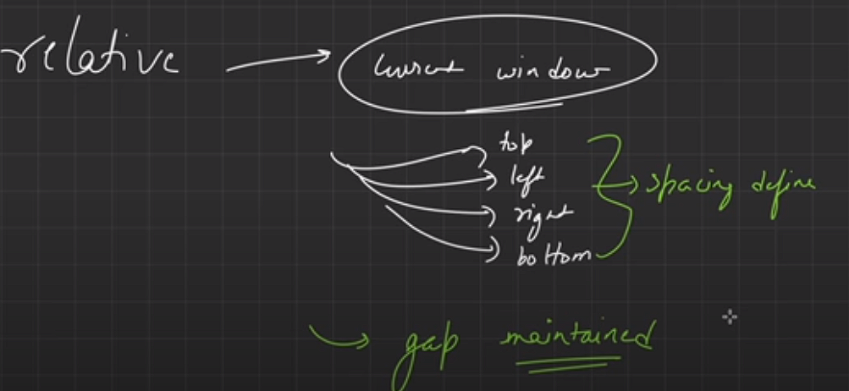

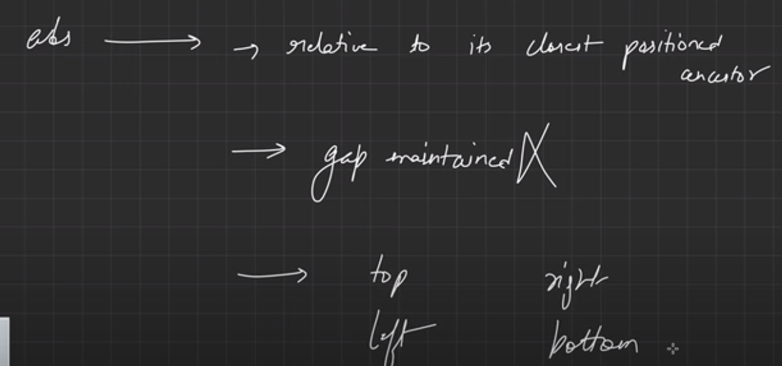

img tag is an inline element but it behaves like an inline-block

<img> tag is an inline-block element because it takes only content width and we can also set margin, padding, and custom width and height.

**CSS size Unit:- Absolute unit and Relative unit.**

**Difference between physical and logical pixel.**

**Difference ppi and dpi**

**Default font size is 16px**

**em is relative unit which is dependent on parent class for example if 4em means 4*16=64px**

**rem is relative unit dependent on a root element and root element default configuration is 16 px.**

Physical pixels refer to the actual individual dots that make up a display screen, while logical pixels are a virtual measurement used for consistent layout and scaling in software development across different devices. PPI refers to the number of pixels per inch on a digital display, while DPI refers to the number of dots per inch that a printer can produce. PPI is relevant for screens and displays, while DPI is relevant for printed materials.

Pixels per inch (PPI) refers to the number of pixels contained within each inch of a digital image. DPI stands for Dots per Inch, referring to the number of ink droplets a printer will produce per inch while printing an image. The more dots of ink per inch the picture has, the more detail you will see when printed.

To increase responsive property we can use: media queries property. (We always try to develop in low dimension let's say mob view, the using min width we can break down.) display : flexbox unit will also help us, as it will give us a chance to display divs in row or column wise using wrap or no wrap. Using of relative property like %, vw, vh. By giving a height a width in html and fix width by max() or min() function, and height : auto property, using calc() function will also help us in this case,

Show less

***For resoponsive design or website try to make sure use relative unit so that your UI does not change by changing dimension.***

**The float property in CSS is used for positioning and layout on web pages. A common usage might be floating an image to one side and letting text wrap around it.**

The **overflow** [CSS](https://developer.mozilla.org/en-US/docs/Web/CSS) [shorthand property](https://developer.mozilla.org/en-US/docs/Web/CSS/Shorthand_properties) sets the desired behavior when content does not fit in the parent element box (overflows) in the horizontal and/or vertical direction.

Lecture 19-> Overflow alternative: [17:50](https://www.youtube.com/watch?v=eMrjjsnQUDw&t=1070s):As we are using width and height with the unit of px in the example of overflow, but if we use the unit of % that adjusts his height according to the parent, so, in this case, the parent is <body> means viewport. So if we use % then it automatically adjusts the overflow content.

**Flexbox:- stand for flexible box, ability to align and place different items in a layout.**

The Flexible Box Layout Module, makes it easier to design flexible responsive layout structure without using float or positioning.

it is a 1D layout method, we can do row-wise layouting and column layouting.

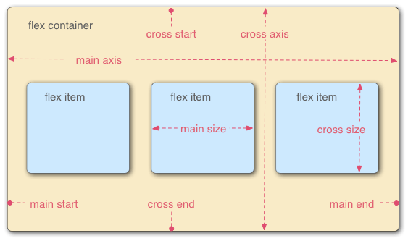

Whenever we want to convert any container or div into flex we have to mark it display:flex

And it behaves as flex container and its items within it behaves as flex items. And by default flex direction would be row-wise.

Responsive web design or responsive design is an approach to web design that aims to make web pages render well on a variety of devices and window or screen sizes from minimum to maximum display size to ensure usability and satisfaction.

Responsive design is an approach to web design in which the interface adapts to the device's layout, facilitating usability, navigation and information seeking.

If you want to make sure that your width does not squeeze according to display screen until space is available then you have to set

flex-wrap:wrap;

The flex-flow property is a shorthand property for setting both the flex-direction and flex-wrap properties. Example:

.flex-container {

display: flex;

flex-flow: row wrap;

}

**Justify-content**:- it places component according to main-axis.

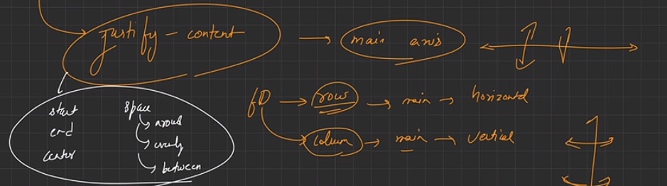

Align items:- flex-start, flex-end, center.

It works according to cross-axis. By default cross-axis is vertical

it controls the alignment of items on the [Cross Axis](https://developer.mozilla.org/en-US/docs/Glossary/Cross_Axis).

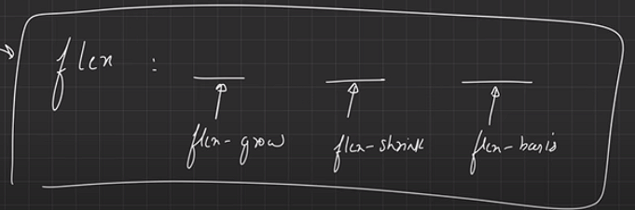

Short hand notation

**Flex-basis** is used to set the dimension of flex items. Like flex-basis : 200px;

**Align-self** -  it aligns the item inside the [grid area](https://developer.mozilla.org/en-US/docs/Glossary/Grid_Areas). In Flexbox, it aligns the item on the [cross axis](https://developer.mozilla.org/en-US/docs/Glossary/Cross_Axis).

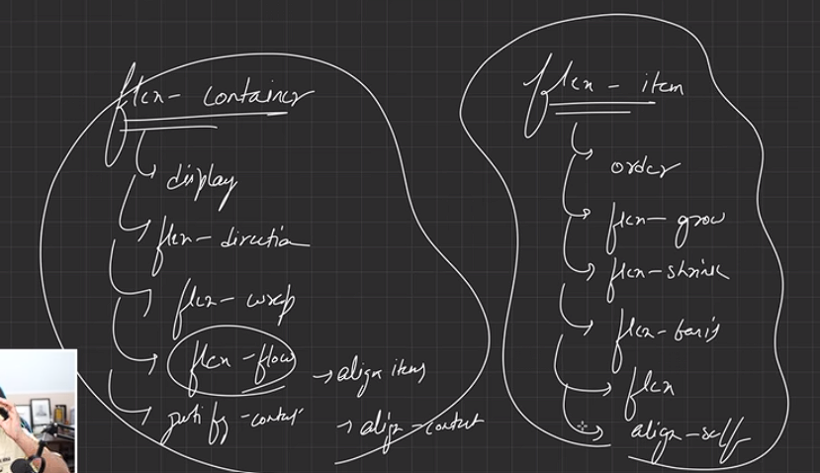

NOTE:-

Whenever flex direction is row then your justify-content is row-wise(horizontal) and align-items is column wise(vertical) and vise-versa.

* The [CSS](https://developer.mozilla.org/en-US/docs/Web/CSS) **justify-content** property defines how the browser distributes space between and around content items along the [main-axis](https://developer.mozilla.org/en-US/docs/Glossary/Main_Axis) of a flex container, and the inline axis of a grid container.

**Media Query :- is a tool in which we can defined the element styling or arrangement on a different screen size.**

**According to display size we can render different CSS configuration with the help of media query.**

If we want greater then 640 then we use min-width:640 and if we want less then 640 then we use max-width:640;

max-width:640px means if the screen size is less than or equal to 640px then apply it

**Read from mdn box-shadow and text shadow:-**

**Animation:-** when an element gradually changes from one style to another style. The information which is stored to change from style1 to style2 is stored in keyframe.

When you specify CSS styles inside the @keyframes rule, the animation will gradually change from the current style to the new style at certain times.

The animation-fill-mode property specifies a style for the element when the animation is not playing (before it starts, after it ends, or both).

When animation-fill-mode is set to both, it means that the styles defined in the CSS rules for the animated element will be applied both before the animation starts and after it ends. In other words, the element will retain the styles of the first keyframe before the animation starts, and it will also retain the styles of the last keyframe after the animation completes.

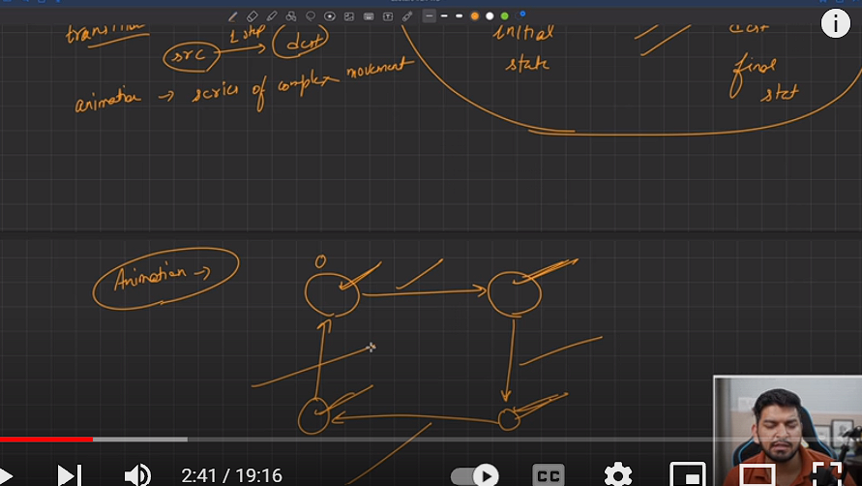**Transition:-**

# Transform

The **transform** [CSS](https://developer.mozilla.org/en-US/docs/Web/CSS) property lets you rotate, scale, skew, or translate an element.

The matrix() property in CSS is a function that defines a **homogeneous 2D transformation matrix.** It can be used to rotate, scale, translate, and skew elements.

The matrix() function takes six parameters, which are described in the column-major order:

a: The x-axis scaling factor.

b: The shearing factor between the x-axis and the y-axis.

c: The y-axis scaling factor.

d: The shearing factor between the y-axis and the x-axis.

e: The x-axis translation.

f: The y-axis translation.

**The matrix() method combines all the 2D transform methods into one**. The matrix() method take *six parameters*, containing mathematic functions, which allows you to *rotate, scale, move (translate), and skew* elements. The parameters are as follow: *matrix(scaleX(), skewY(), skewX(), scaleY(), translateX(), translateY())*